Flipping the Classroom with Video Lectures
Nestor Matthews, Department of Psychology, Denison University
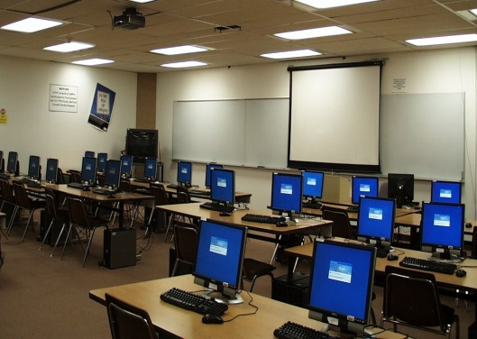

In two of my psychology courses (Research Methods, and Sensation & Perception) I experimented with pre-recording my PowerPoint based video lectures, and storing them on YouTube. Before each class session, students were required to watch the videos and take notes. In this “flipped classroom” arrangement, lectures occurred outside of class (available to students “24/7”); classroom time became “rehearsal time” for interactive discussions and demonstrations. There are several advantages to flipping the classroom with video lectures. First, video lectures facilitate knowledge acquisition by capitalizing on the richness of oral communication, complete with facial expressions, voice inflection, and hand gestures. Second, video lectures create a more equitable learning landscape. Students with diverse native languages, or less typical hearing or motor endowments can rewind the videos as often as necessary, learning the material more completely than would be possible during traditional, fast-paced, catch-it-if-you-can live lectures. Third, by freeing class time for hands-on demos and other activities that require students to produce responses rather than merely receive information, video lectures promote learning-by-doing. Fourth, video lectures improve time management across the semester by ensuring coverage of the most relevant course material before each class period starts. Fifth, video lectures provide opportunities for faculty development, as instructors can identify limitations in their own recordings and receive suggestions from professionals across the world who teach the same topic. Assessment confirms a broader range of students’ in-class participation, and high learning-effectiveness ratings. A video summarizing my experiences with video lecturing can be viewed at http://personal.denison.edu/~matthewsn/flippingtheclassroom, and the poster can be downloaded at http://personal.denison.edu/~matthewsn/nitop2014.
Video
Poster

